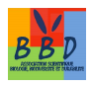

Popular Democratic Republic of Algeria
Mostefa Ben Boulaid University (Batna 2 - Algeria)
Faculty of Nature and Life Sciences (SNV)
Scientific Association 'Biology, Biodiversity and Sustainability' ''BBD"
&
International Organization for Biological and Integrated Control "IOBC-WPRS"

Registration form
The first International Congress on Biological and Integrated Control in Algeria "CILBIA1"
4 - 6 February, 2019

Send the completed form to: cilbalgerie1@gmail.com

Title : Mrs., Miss, Mr., Dr.
First name of the communicant
NAME of the communicant (in CAPTITAL letters)
Co-author names
(maximum of 3 co-authors)
Communication title
(in capital letters)
Institution (Organisation,)
Function of the communicant
E-mail Address
Phone
Desired type of communication*
(Oral / Poster)
Selected theme
(from 1 to 3 – see below)
Type of support
With or without accommodation (see registration fees below)

* The selection of oral/poster communications will be carried out by the Scientific Committee

Important dates
- Deadline for abstract submission : December 13, 2018
- Notification of acceptance : January 6, 2019
- Publication of the final program and invitations : January 20, 2019
- Deadline for full paper submission : February 4, 2019
- Congress dates: 4-6 February, 2019

Scientific themes:

- Bio-ecological knowledge and assessment of damages caused by plant diseases, weeds and pests / disease vectors in agrosystems, forests and urban environments (human health)
- Biological and integrated protection of crop as a means of preserving biodiversity
- Phytosanitary product registration procedures and risk assessment and biosecurity

Registration fees :
- Including hotel accommodation:
  - Teachers, researchers and other employees: 15.000 DA (120 Euros)
  - Non-salaried students (PhD/MS students): 10.000 DA (80 Euros)
- Without housing:
  - Teachers, researchers and other employees: 6000 DA
  - Non-salaried students (PhD/MS students): 4000 DA
- Exhibition booths : 20.000 DA (150 Euros)

Registration fees including hotel accommodation cover:
- Briefcase with congress documents and participation certificate in CILBIA1
- Lunch and coffee breaks on February 5th
- Dinners and hotel nights of 4, 5 and 6 February
- Post-conference excursion with traditional lunch on February 6th
- Possibility of abstract/full paper publication in the IOBC-WPRS Bulletin

Registration fees without accommodation cover:
- Briefcase with congress documents and certificate of participation in CILBIA1
- Lunch and coffee breaks on February 5th
- Possibility of abstract/full paper publication in the IOBC-WPRS Bulletin
- Payment of registration fees in cash upon arrival at the congress venue.

Recommendations for oral presentations and posters:

- Oral presentations must not exceed 10 minutes and must be saved on the laptop of the seminar before the start of the scheduled session
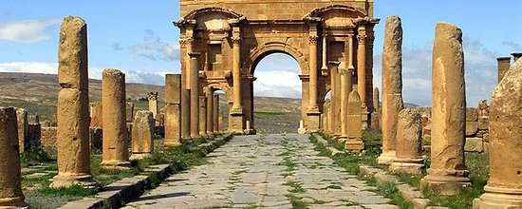
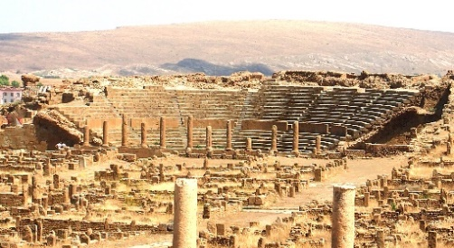
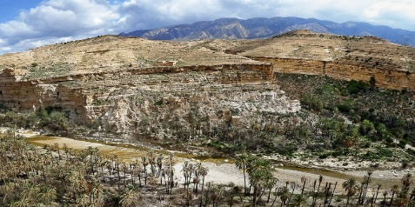
- Posters must have a maximum ''A0'' size (84.1 x 118.9 cm) and a minimum size of
60 x 80 cm with a font sizes that allows reading from a distance of at least one meter.
Welcome to CILBIA1

